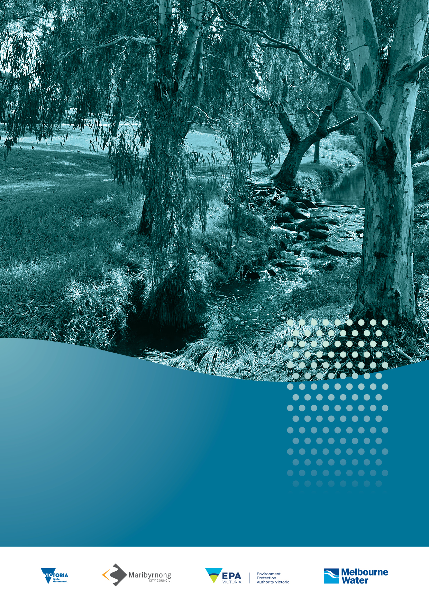
Stony Creek
Rehabilitation Plan
Annual report card

2021 – 2022

Contents
1. Overview 4
2. Highlights 11
Litter investigation shows how to make a big impact
on litter hotspots 11
Industrial past and impacts of the fire are reflected
in water quality review 13
Water sensors detect pollution events in real-time 14
New regulatory regime shifts focus from reaction
to prevention 15
3. Report card 17

Acknowledgement of Country
Melbourne Water respectfully acknowledges the Bunurong, Gunaikurnai, Taungurung, Wadawurrung and Wurundjeri Woi-Wurrung peoples as the Traditional Owners and Custodians of the land and water on which we rely and operate. We pay our deepest respects to their Elders past, present and emerging.
We recognise Bunurong as the Traditional Owners and Custodians of the Country through which lower Stony Creek winds and joins Port Phillip Bay and the Wurundjeri Woi-Wurrung as the Traditional Owners and custodians of the country through which upper Stony Creek meanders. We recognise and respect the continued cultural and spiritual connections that Aboriginal and Torres Strait Islander peoples have with land and water they have cared for and protected for thousands of generations.
We demonstrate our ongoing commitment to reconciliation through our partnerships with Traditional Owners and the broader Aboriginal and Torres Strait Islander communities, as we work together to manage land and water now and into the future, while maintaining and respecting cultural and spiritual connections.

1. Overview
Significant progress has been made by Melbourne Water, Maribyrnong City Council, Environment Protection Authority Victoria (EPA Victoria), research partners and the local community to deepen our understanding and improve the way we rehabilitate and protect Stony Creek following the August 2018 Tottenham warehouse fire.
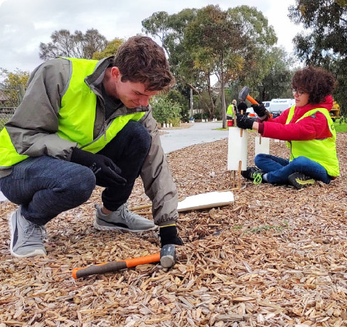
Friends of Cruickshank Park National Tree Day Community Planting Day August 2021
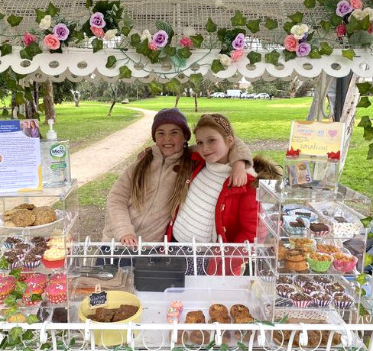
Friends of Cruickshank Park Sweet Charity fundraising cart on loan to local community groups
Since the Stony Creek Rehabilitation Plan (2019-2029) (the Plan) was released in 2019, a large proportion of the actions outlined are in progress, or have now been completed. The Plan was developed through close consultation with local community members, organisations and government agencies who will continue to implement the actions in the coming months and years.
Melbourne Water, project partners and the community will continue to work together to restore, enhance and protect the condition of the creek and its surrounding environment throughout the 10-year program of actions and into the future.
This is the Plan’s third annual report card and provides an update on the status and progress of actions from September 2021 to August 2022.
This report card includes 23 actions delivered this year; eight are complete and 15 are in progress.
The projects that have progressed this year include new infrastructure, regulatory changes, community education and research projects that help to inform how we improve waterway health. The range of work in progress includes planting and weed removal that create habitat for frogs and birds, improved access to the creek for visitors and improvements in how we manage pollution throughout the Stony Creek catchment.
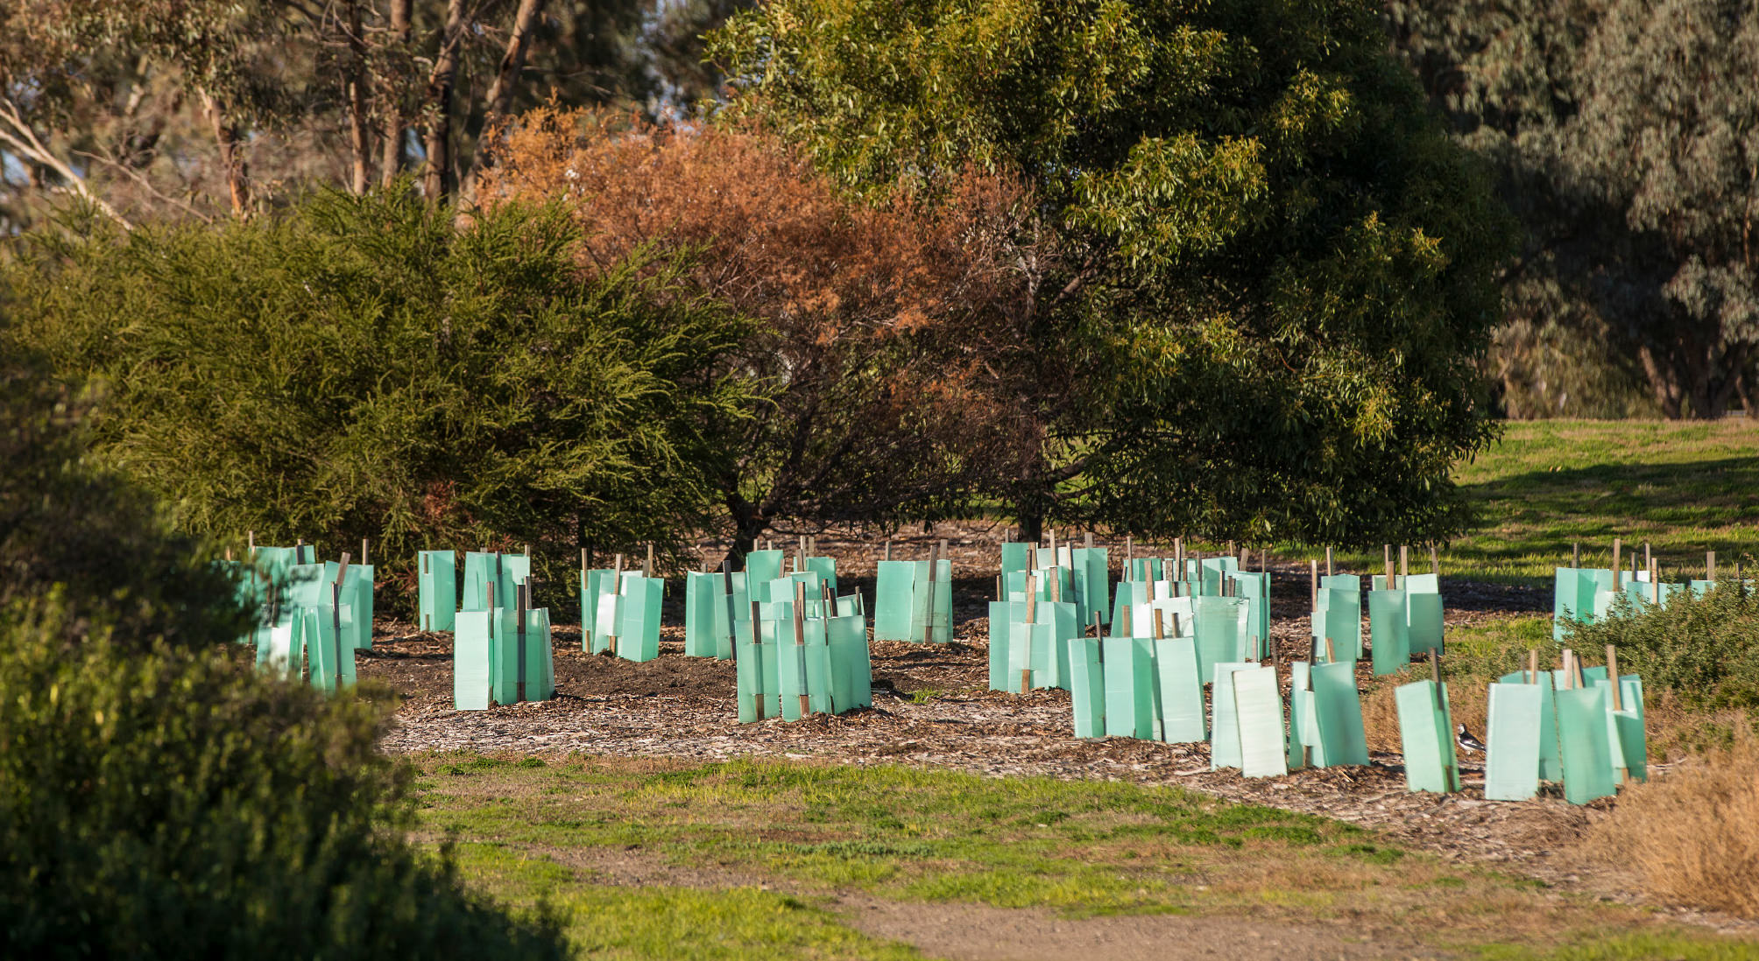
Planting in the Stony Creek catchment
Friends of Stony Creek and Friends of Cruickshank Park community groups hosted a range of activities throughout the year creating opportunities for the community to learn about and connect with the creek. Events involved actively monitoring water quality in the creek and planting over 450 plants that support the green corridor across Melbourne’s western suburbs.
Research collaborations that investigate the key drivers of poor water quality have advanced our understanding about litter and other pollutants that impact Stony Creek. Melbourne Water, Maribyrnong City Council and EPA Victoria are working together with Monash University on the delivery of a water quality sensor project and with RMIT University to investigate litter and contaminants that impact the catchment. Each project produced several recommendations that describe the actions needed to protect and improve the health of the creek. See more about these innovative projects in the highlights sections and report card below.
Since the Plan was released in September 2019, over 75 per cent of the actions that were initially developed have been completed or are in progress. The figure on page four highlights the overall progress. Among the achievements are actions that fall under five key themes:
1. Waterway health
2. Water quality
3. Education and participation
4. Amenity
5. Access

Progressing the Stony Creek Rehabilitation Action Plan 2019–2029
The Plan establishes the foundation for the rehabilitation and protection of Stony Creek following the fire incident in August 2018.

Location
The Plan focuses on a five kilometre stretch of Stony Creek from the fire site in Tottenham to the Stony Creek Backwash (estuary) in Yarraville, within the local government areas of Maribyrnong City Council and Hobsons Bay City Council.
In 2019, a group of passionate community representatives participated in an independent workshop to inform the development of the Plan. Participants created an aspirational vision for Stony Creek that we are working together to implement.
We want to transform Stony Creek to be Australia’s best protected, connected and respected urban waterway – a healthy and clean natural community asset that consistently supports a thriving ecosystem. Once it’s completed, we want the Stony Creek Rehabilitation Project to be seen as a showcase for how community, government and business can partner to achieve enduring physical, social and ecological health benefits. The final outcome will connect communities to each other, communities with nature, and allow life to thrive in and along Stony Creek for generations to come.
Community Vision
Stony Creek Rehabilitation Plan 2019-2029
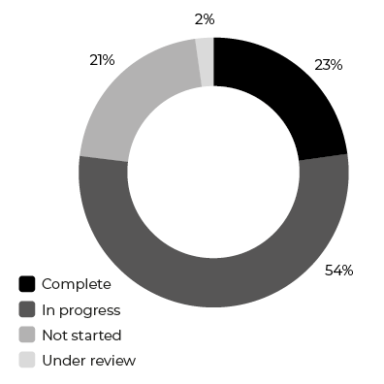
Status of actions since the Plan was implemented in 2019
Working together we have completed 12 actions to restore, enhance and protect Stony Creek into the future.
We have started to deliver 28 actions that are currently in progress towards our long-term, aspirational vision for Stony Creek, and 11 new actions are being developed.

Our progress
The actions in the Plan are categorised under five key themes that capture the community’s ideas and aspirations for the rehabilitation of Stony Creek. Since the Plan’s inception, significant progress has been made.

1. Waterway health
Planting trees and vegetation to improve habitats and local biodiversity.

Complete
A number of community planting days have been held by Friends of Cruickshank Park and their Junior Ranger program, Friends of Stony Creek and Maribyrnong City Council. A vegetation improvement project was also delivered by Melbourne Water. In total, over 6,000 trees and plants have been planted for local biodiversity within the creek corridor.

Complete
A new frog pond at Drew Street, Yarraville has been constructed and abundant frog calls have been heard from their new refuge habitat.

2. Water quality
Treating stormwater, litter control and preventing pollution.

Complete
A Water Sensitive Urban Design (WSUD) Officer, employed by Maribyrnong City Council for an 18 month period, developed WSUD guidelines that, among other benefits, resulted in better coordination of council’s stormwater assets.

In progress
We are applying Water Sensitive Urban Design (WSUD) features, like raingardens, that improve water quality.

3. Education and participation
Improving community, industry awareness and knowledge about the creek.

Complete
Maribyrnong City Council’s ‘My Smart Garden’ program ran two Frog Bog workshops and one self-watering garden workshop during 2019. The ‘My Smart Garden’ program is ongoing and promotes habitat planting and sustainable gardens to the community.

In progress
Friends of Cruickshank Park Junior Ranger program have continued monitoring the 20 nest boxes established in Cruickshank Park using mobile telescopic cameras. This information is used as an educational tool, and importantly, to ensure the boxes are providing shelter to native fauna.

4. Amenity
We are creating cool and shady spaces to escape the busy urban landscape, to meet with friends and family, to exercise and connect with nature.

Complete
Melbourne Water has been working with Parks Victoria, Maribyrnong City Council and Hobsons Bay City Council to make sure weed control efforts are aligned and working together along the entire extent of Stony Creek.

Complete
A new toilet block at Cruickshank Park and a new barbecue area at McNish Reserve have been constructed. The new facilities are used by the community to enjoy their local reserves surrounding Stony Creek.

In progress
The West Gate Tunnel Project will be expanding the Stony Creek Reserve between Hyde Street and Williamstown Road by turning vacant industrial land into new open space and planting woodland tree species to increase tree canopy cover.

5. Access
We are improving access and connectivity to the creek.

Complete
A footbridge connecting Park Avenue and Cala Street has been completed, improving community accessibility and safety along this section of Stony Creek.

Complete
Lighting has been installed on the path that connects Austin Crescent East with the Drew Street bridge. This priority location was identified in the Stony Creek Future Directions Plan for improved lighting that provides safe connections to the surrounding street network.

In progress
Pedestrian and bike crossings have been investigated to improve pedestrian connectivity, efficiency, and safety at the Geelong Road and Somerville Road intersection. Additional safety improvements are being sought from the responsible authority for pedestrians.

Status of actions under each key theme | Complete | In progress | Not started | Under review
Waterway health | 4 | 4 | 1 | 1
Water quality | 1 | 7 | 2
Education and participation | 3 | 8 | 1
Amenity | 2 | 6 | 3
Access | 2 | 3 | 4

2. Highlights

Litter investigation shows how to make a big impact on litter hotspots
The Stony Creek whole of system litter investigation and management prioritisation project was initiated by Melbourne Water in response to Water Quality Action 9: Place litter traps in appropriate places throughout the Stony Creek catchment. In collaboration with Melbourne Water, the RMIT University research team conducted litter surveys of the stormwater drains and the banks of the creek. These surveys helped identify how much and what types of litter are impacting the creek from different sources.
The litter investigation showed what actions would be most effective in managing the litter. A range of recommendations are included in the final report RMIT University - Stony Creek Litter Project.
The recommendations are based on six key approaches and these are prioritised according to the waste risk management hierarchy (Figure 1), and include:
- Education and awareness
- Enforcement and regulation
- Improving knowledge
- Partnerships and capacity building
- Infrastructure and services
- Clean up activities

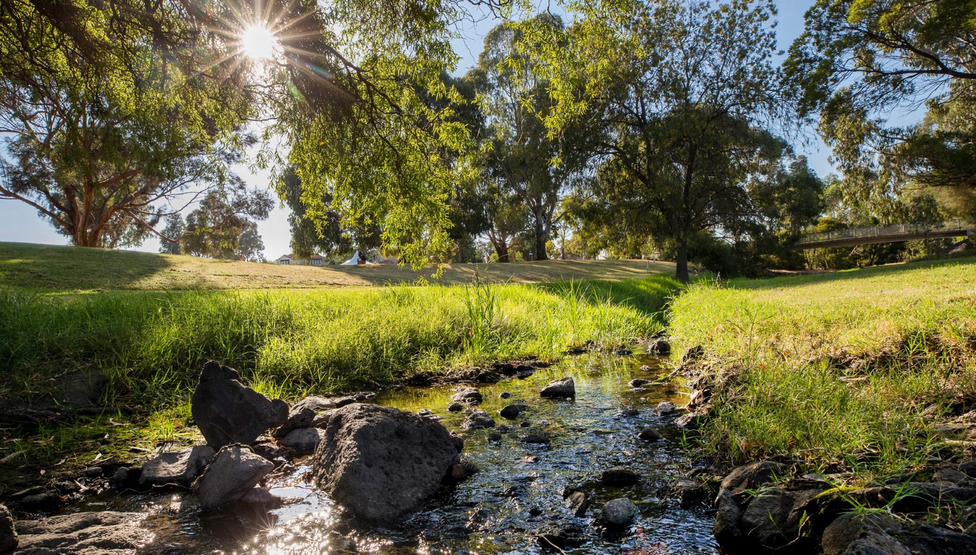
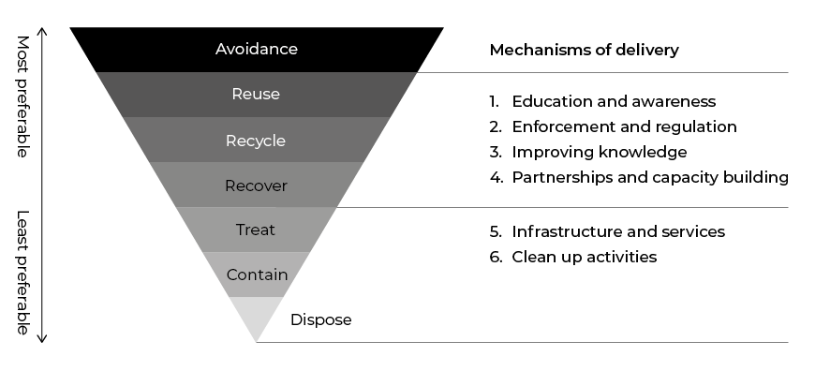Figure 1. The waste management hierarchy. Mechanisms of delivery in green are focused on prevention and reuse, while those in blue are treatment and disposal based options
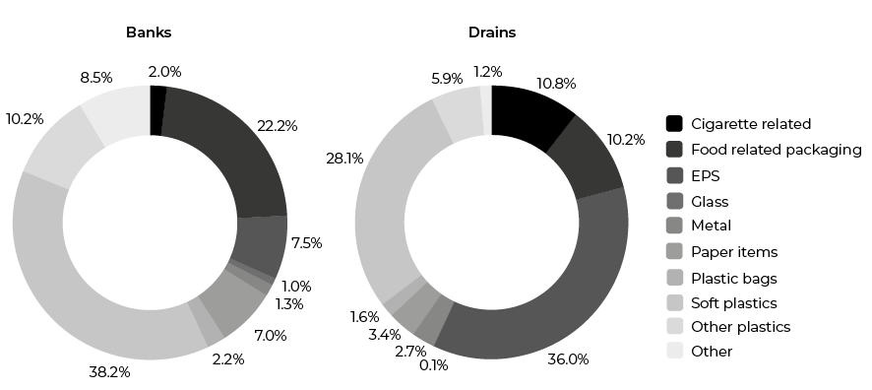Figure 2. Contributions of different litter types in bank and stormwater drain surveys
Drains N = 1031; Banks N = 1899
Source: A3P Project: Stony Creek whole of system litter investigation & management prioritisation Targeted Litter Surveys Summary Report

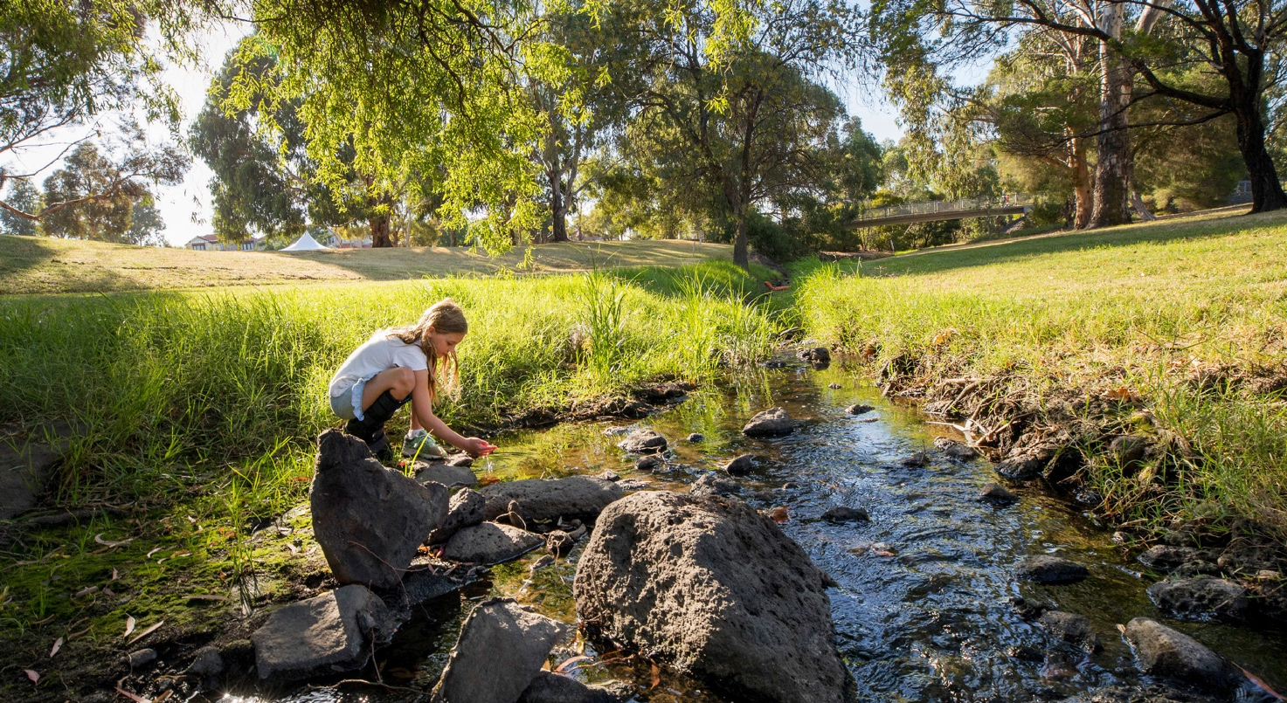
The option to install a litter trap at Matthews Hill Reserve or Thomas Street was identified as a potential infrastructure action, however it did not rank as high in prioritisation and capitalisation. Other options were deemed less costly and safer recommendations that aimed to address litter closer to its source.
Melbourne Water has shared the findings with Maribyrnong City Council and we will be working together to review the feasibility of and prioritise the management recommendations. This will include reviewing what is already being conducted within the agencies, uplifting existing programs and services in light of the findings, and considering additional activities.
Litter is a key concern within the community and its presence erodes the amenity value of our waterways, including the Stony Creek corridor. The RMIT Whole-of-System Litter Investigation has identified the key hot spots for litter along Stony Creek and the composition of litter encountered within these areas. This provides insights into the source of the litter and enables agencies to best target interventions to address litter generated within the wider catchment and reduce the quantity making its way to the waterway.
Jesse Barrett
Maribyrnong Area Manager Waterways and Catchment Services Operations, Melbourne Water
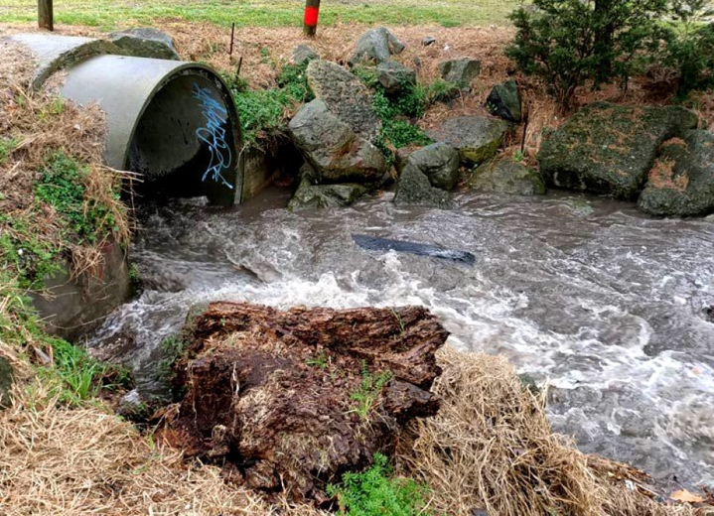
Stony Creek stormwater drain in high flow, with a black mesh sampling bag suspended midstream
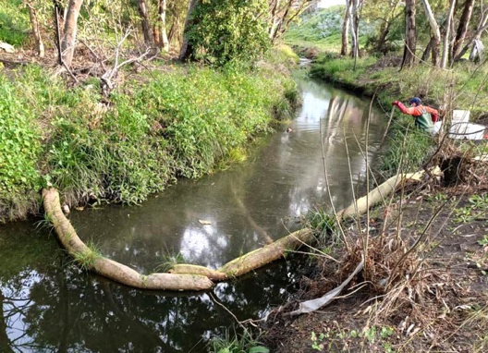
RMIT Aquatic Pollution Prevention Partnership (A3P) researcher collecting samples upstream of a pollution barrier sausage in Stony Creek

Industrial past and impacts of the fire are reflected in water quality review
In 2021, Aquatic Environmental Stress Research Group (AQUEST) from RMIT University monitored the water and sediment quality in Stony Creek using passive samplers and sediment bags. Passive samplers are devices that remain in the creek and absorb any micropollutants present in the water. Once removed from the water, the devices are taken back to the lab where the micropollutants can be identified. The results of this program were reviewed by RMIT University in conjunction with historical data that describes the contaminant profile for Stony Creek and identifies post-fire management interventions to improve water quality.
The RMIT University - Review of Historic and Recent Water Quality in Stony Creek, makes recommendations for managing key contaminants in Stony Creek. Working together Melbourne Water, Maribyrnong City Council and EPA Victoria reviewed these actions to find opportunities to manage key contaminants. The real-time sensor project that is currently underway by Monash University (see below) is one example of how we are putting recommendations into action.
Next year’s report card will include information about an additional research project that is currently in development. This project will assess the feasibility of using filtration material within stormwater drains to remove key contaminants.
Stony Creek is a highly urbanised waterway with a large level of industry within the contributing catchment. The RMIT review recognised that stormwater drains are a significant conduit for pollution. Addressing this issue will take a multi-pronged approach, and Melbourne Water is working with the EPA Victoria to progress priority management recommendations highlighted in the report. This includes using real-time sensors to track pollution sources within the catchment to target compliance and education activities, and investigating potential online water quality treatment infrastructure options.
Jesse Barrett
Maribyrnong Area Manager Waterways and Catchment Services Operations, Melbourne Water

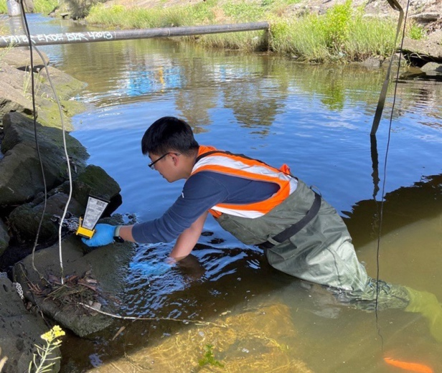
Monash University researcher installing water quality sensors in Stony Creek
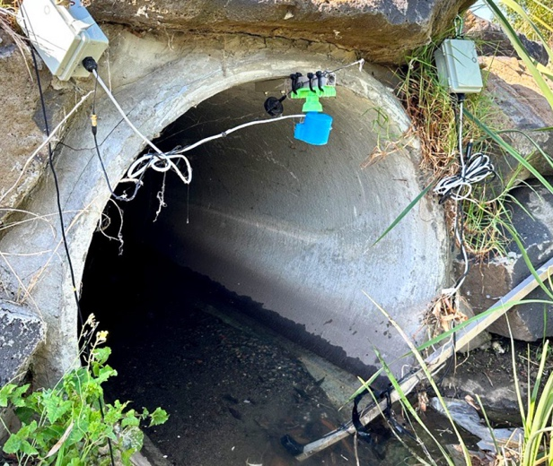
Above stream water sensor installed as part of the research trial in Stony Creek

Water sensors detect pollution events in real-time
The Real-time sensing framework for pollution detection and response in the Stony Creek catchment trials a new sensor network that can detect pollution events as they happen.
Monash University, in collaboration with Melbourne Water and EPA Victoria, have developed a water quality sensor network in the industrial areas of the Stony Creek catchment. The sensor network will show where and when pollution events occur. This technology will help determine the source of pollution and enable a more effective response to sudden changes in water quality. The data will be assessed by technical experts online and has the potential to be a powerful tool to understand pollution trends and identify hotspots.
Work undertaken this year included the analysis of existing data that helped the project team identify the best placement of 30 low-cost sensors. The locations selected included areas where the pollution risk was high. The sensor network was deployed throughout the catchment, across ten sites to detect water quality changes in drains and in stream.
The data will be continuously interrogated for a six-month period by researchers and project partners. This trial period explores how we could use this information to respond to unusual changes in water quality that the sensors detect and that could indicate an ensuing pollution event. If the levels exceed certain set-points, text messages and email alerts are sent out to a priority list of field staff.
Project partners continue to work closely together to learn more about reading the data and how to optimise the way Melbourne Water and EPA Victoria respond to these insights. The aim is to identify sudden changes in water quality that show an illegal release of contaminants in the Stony Creek catchment. The data collected will identify problem areas and enable EPA Victoria to target pollution hotspots in the most appropriate manner. This may include site inspections, educational training and/or enforcement.
Industrial areas make up a significant area of the Stony Creek catchment covering over 50km². It’s difficult for EPA officers to trace pollution from stormwater drains to the source. The water quality sensor network project allows EPA officers to respond to pollution as it happens using low-cost sensors and telemetry to notify officers immediately when there is a change in water quality parameters. It also allows EPA to monitor water quality trends to inform strategic regulatory projects.
Steve Lansdell
Regional Manager, West Metropolitan Melbourne Region, EPA Victoria

New regulatory regime shifts focus from reaction to prevention
Recent changes in legislation made a significant difference to Victoria’s regulatory approach to environmental protection. During proactive and responsive inspections in the Stony Creek catchment, EPA Victoria engaged and educated industry about better practices and helped businesses to understand their stormwater quality obligations. New prevention resources were developed about specific practices and activities that are common across several industry sectors. For example, guidance was provided about safe storage and handling of liquid waste that could harm the environment if it were not stored and managed in the right way.
EPA Victoria also worked with Maribyrnong City Council through the Officers for the Protection of the Local Environment (OPLE) program to prevent illegal waste stockpiling, inappropriate storage and handling of wastes and their risks to the environment.
This prevention-based approach is supported by EPA Victoria’s new General Environmental Duty (GED) that came into effect on 1 July 2021. This important change, along with a suite of amendments to the Environmental Protection Act 2017, gives Victoria modernised environmental protection laws. The new laws strengthen EPA Victoria’s capacity to take targeted and effective action to protect the environment. This is reflected in the prevention activities that are undertaken in the Stony Creek catchment and will continue into the future.
The GED makes it clear that businesses have a responsibility to reduce risk to human health and the environment. Our EPA officers use a range of regulatory tools, from remedial notices to compliance advice, to address issues that have the potential to impact Stony Creek. Our EPA officers also make sure businesses know about State of Knowledge – all the information you should reasonably know about managing your business’s environmental risks. In the Stony Creek catchment EPA has conducted 40 inspections for the year 2021/22 an increase of approximately 5% to the previous year.
Steve Lansdell
Regional Manager, West Metropolitan Melbourne Region, EPA Victoria

3. Report card
The report card includes status updates on 23 actions. Actions across the years of 2019 to 2029 are in the report card, including actions to be reported on annually and actions that have been completed ahead of schedule. For a full list of actions for the 10-year program, please see the Stony Creek Rehabilitation Plan (2019–2029).
As outlined in the Plan, each action has a code (e.g. WH 1, WH 2 etc) which indicates its priority (1 being highest priority; 10 being lowest priority). These were ranked in priority order according to the community. Completed actions from previous year’s report card are not in this table.
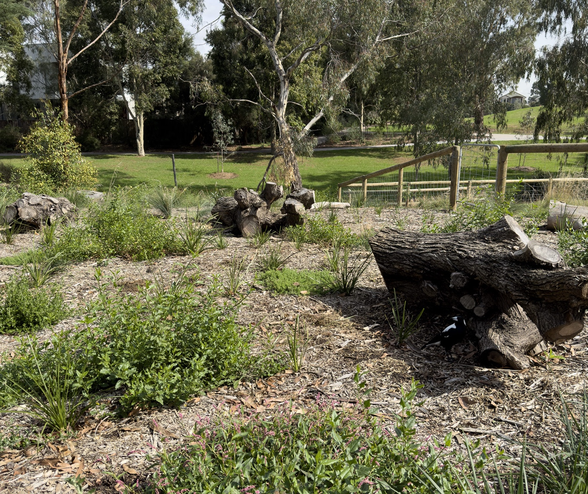
Court Street Raingarden at Cruickshank Park, Yarraville

Key theme | Code | Action | Lead | Support | Year due | Status information  as at August 2021 | Status
Waterway Health | WH 1 | Investigate reasons for poor water quality (e.g. low dissolved oxygen levels) in Stony Creek and develop options and/or strategies to improve them | Melbourne Water  EPA Victoria | Maribyrnong City Council | 2020 | An investigative project was completed by RMIT University to understand key drivers of poor water quality in Stony Creek. The report provides recommendations on feasible options to address water quality issues, which are currently being utilised by Melbourne Water and the EPA Victoria to inform the management actions that will follow.  The report is available at:  Stony Creek Contaminant Review | Complete
Waterway Health | WH 2 | Gain access to areas of the creek corridor that are in private ownership so that the creek’s health and public access to it can be managed in a connected way | Maribyrnong City Council | Melbourne Water | 2029 | Maribyrnong City Council’s Stony Creek Future Directions Plan 2020 includes a vision for continuous public open space corridor along the creek, including an area requiring a Public Acquisition Overlay.  Maribyrnong City Council is preparing an amendment to the Planning Scheme to ensure appropriate controls are in place. | In Progress
Waterway Health | WH 4 | Create off-stream habitats for frogs and birds | Melbourne Water | Maribyrnong City Council  Community groups  (eg. Friends groups)  Public land managers  Private landowners | 2022 | A Melbourne Water habitat and amenity improvement project was completed in 2022 that has provided bird and frog habitat through streamside revegetation, weed control and creation of a new frog pond at Drew Street, Yarraville. Over 2,000 native plants were established through the project along Stony Creek. Frogs have successfully colonised the frog pond, and survey data continues to be collected through citizen science monitoring via the Frog Census App.  A second frog pond was planned at Bishop Street, Yarraville and designed to be fed by a proposed Council raingarden. As the Bishop Street raingarden was unable to proceed (refer to WQ4), the connecting frog pond has likewise been discontinued. | Complete
Waterway Health | WH 7 | Plant native vegetation to establish a continuous corridor along Stony Creek. Design revegetation to retain important sightlines in public areas | Melbourne Water | Maribyrnong City Council  Community groups (eg. Friends groups)  West Gate Tunnel Project  Traditional Owner groups | 2022 | Friends of Cruickshank Park Junior Ranger program completed planting and weeding activities along the creek. Junior Rangers participated in one of two community planting days held in May and June 2022 by Friends of Cruickshank Park.  Friends of Stony Creek held a successful community planting and weeding day in Hyde Street reserve in May.  Plantings provide habitat for local fauna such as skinks and owls.  Refer also to the Melbourne Water project update against WH4. | In Progress
Water Quality | WQ 2 | Install water quality sensors throughout the catchment to investigate sources of pollution and litter, and enable a targeted response | Melbourne Water  EPA Victoria | Maribyrnong City Council | 2019 | A water quality sensor project in partnership with Monash University kicked off in 2022. The project has deployed sensors in the Stony Creek stormwater network to monitor dry weather flows in real-time. The aim of this project is to develop our understanding of when and where pollution events are occurring in the catchment, and provide authorities with information to target inspections. The sensors will remain in situ until April 2023. EPA Victoria and MW are currently working with the research team on how to utilise the real-time sensor data to trigger and inform operational responses to pollution events.  See highlights for further information. | In Progress
Water Quality | WQ 3 | Work with industry to ensure compliance regarding stormwater management and pollution prevention | EPA Victoria | Melbourne Water  Maribyrnong City Council | 2029 (Annual) | EPA Victoria’s Western Metropolitan Region, Industry Guidance Unit (IGU), Communication and Engagement Group (CEG), and other working groups, have been actively engaging with a wide range of industry groups, and individual business owners across Victoria. Environment Protection Officers (EPO’s) and Officers for the Projection of the Local Environment (OPLE’s) have provided educational and guidance material to businesses inspected, in the Stony Creek catchment, to improve knowledge and understanding of the Environment Protection Act 2017.  EPA Victoria officers continue to inspect and work with businesses in the Stony Creek catchment to provide advice, guidance and regulatory actions that improve business knowledge, understanding and compliance with the prevention-based Environmental Protection Act 2017. | In Progress
Water Quality | WQ 4 | Implement Water Sensitive Urban Design (WSUD) features in appropriate locations (e.g. raingardens, permeable pavements, road run-off diversion to median strips, swales, streetscape features etc.) | Maribyrnong City Council | Melbourne Water | 2029 | Construction of the first stormwater treatment raingarden identified in the Stony Creek Future Directions Plan was completed in January 2022 by Maribyrnong City Council. The raingarden is located in Cruickshank Park and will improve the quality of water flowing into Stony creek from the Court Street drain.  Construction of a second raingarden to treat water from the Bishop Street drain commenced in November 2021. However, soil contamination encountered on site, impacted upon the feasibility of this project and it was discontinued. The site has since been remediated to its former condition. | In Progress
Water Quality | WQ 5 | Provide incentives for private and public landholders to implement stormwater quality improvement measures on their land | Melbourne Water | Water Quality | 2029 (Annual) | EPA Victoria’s Industry partnership program enabled 17 Victorian industry organisations to partner with EPA Victoria to provide training on the new environment protection laws.  Industry Partnership Program  EPA Victoria’s Small Business Program pilot offered free expert advice about managing risks under the new environment protection laws to eligible small businesses across Victoria.  Small Business Program pilot  Melbourne Water’s Liveable Waterways and Liveable Communities Program provides incentives for Integrated Water Management (IWM) initiatives ranging from precinct to regional scale that facilitate multi-partner IWM, influence industry and address existing barriers to implementation. The Liveable Waterways and Liveable Communities (LWLC) incentives program continues to support local councils and other public landholders to deliver stormwater quality improvement measures on their land. | In Progress
Water Quality | WQ 9 | Place litter traps in appropriate places throughout the Stony Creek catchment | Melbourne Water | Maribyrnong City Council  EPA Victoria  Brimbank City Council | 2021 | Melbourne Water led the development of a litter source reduction plan to identify and address the major types and sources of litter (e.g. ‘hotspots’) in the Stony Creek catchment. The investigation and plan, developed by RMIT University researchers, forms the evidence from which agencies and the community can target activities to reduce litter. Collaboration between council, community and Melbourne Water is required to review, prioritise and deliver on the litter source reduction plan’s recommendations and is planned to occur during the 2022/23 period.  The Stony Creek Whole of System Litter Investigation & Management Prioritisation report can be viewed here:  Stony Creek Litter Project | In Progress
Water Quality | WQ 10 | Regular reporting by Council and EPA Victoria on compliance with stormwater management regulations across the catchment | Maribyrnong City Council  EPA Victoria | — | 2029 (Annual) | EPA Victoria received 60 pollution reports in and around Stony Creek catchment for the financial year 2021/2, which included 48 follow up inspections. EPA Victoria publishes annual statistics on inspections and pollution reports on an ongoing basis. | In Progress
Education & Participation | E 1 | Engage and educate industry about better practices | EPA Victoria | Maribyrnong City Council | 2029 (Annual) | EPA Victoria engaged and educated industry about better practices and their understanding of stormwater quality obligations during routine inspections in the Stony Creek catchment. This included actions as part of WQ 5 and WQ 10 as well as the development of prevention focussed guidance on specific practices and activities common across several industry sectors (e.g. liquid waste storage and handling).  In particular, EPA Victoria and Council worked together through our Officers for the Protection of the Local Environment (OPLE) program to prevent illegal waste stockpiling, inappropriate storage and handling of wastes and their risks to the environment.  EPA Victoria reports on the success of engagement with industry through this annual report card on progress of actions. | In Progress
Education & Participation | E 3 | More signage along the creek (especially in parks) about littering, impacts on stormwater, and directional signage to the community garden and other assets | Maribyrnong City Council | Melbourne Water  EPA Victoria | 2021 | Maribyrnong City Council are planning to install interpretive signage on the benefits of raingardens following the completion of the first and subsequent raingardens along Stony Creek.  Interpretive signage has been installed alongside the Drew Street frog pond by Melbourne Water on the design and intent of the biodiversity asset as part of WH4. The sign includes QR codes which link directly to the frog census page. | In Progress
Education & Participation | E 4 | Community education around rainwater harvesting on residential sites – support for residents to invest in hardware | Maribyrnong City Council | — | 2020 | As part of its Sustainable Design Assessment in the Planning Process (SDAPP) program, Maribyrnong City Council has developed educational resources on stormwater management and water efficiency for planning applicants. These provide guidelines to assist implementation and outline mandatory requirements and best practice standards.  Factsheets can be found on Council’s website at: Sustainable Design Assessment in the Planning Process | Complete
Education & Participation | E 8 | Routine publishing of test results on publicly available websites | EPA Victoria  Melbourne Water  Maribyrnong City Council | Community groups  (eg. Friends groups) | 2029  (Annual) | EPA Victoria’s publication 1872 provides Stony Creek water quality monitoring results downstream of the 2018 Tottenham chemical storage factory fire.  1872: Stony Creek monitoring update  EPA Victoria forecasts water quality for 36 beaches in Port Phillip Bay  Beach Report  EPA Victoria also issues alerts when there is an issue affecting a water body in Victoria.  Water quality alerts  Friends of Stony Creek have been actively monitoring a Stony Creek site downstream of Somerville Road, Yarraville and submitting their results to Waterwatch. This data and information on community water monitoring is available at: Waterwatch Victoria | In Progress
Education & Participation | E 12 | Develop regulations holding industrial groups accountable for damage, continue to inform and support these groups to make better choices in their industrial practices | EPA Victoria | Maribyrnong City Council | 2020 | EPA Victoria operates under the Environment Protection Act 2017 to meet the environmental challenges facing Victoria. The new July 2021 enhanced powers aim to prevent risks to the environment and human health, supported by stronger sanctions and penalties to hold environmental polluters to account.  EPA Victoria’s work with industry associations, state government, local councils, community groups and others contribute to a state of knowledge about managing the risks of harm to business activities that may pose risks to human health and the environment from pollution or waste.  EPA Victoria supports business with guidance under environment protection laws by providing information supporting businesses to understand their environmental obligations under new environment protection laws. | Complete
Amenity | AM 1 | Add more plantings throughout the Stony Creek corridor | Maribyrnong City Council  Melbourne Water | Community groups (e.g. Friends groups)  Public land managers  Private land owners  West Gate Tunnel Project | 2022 | Please refer to WH4 and WH7.  The West Gate Tunnel Project is due to commence plantings in the lower Stony Creek corridor in late 2023 as part of their waterway enhancement works. | In Progress
Amenity | AM 2 | Investigate the acquisition of land adjacent to the creek through sections of private ownership and widen the corridor | Maribyrnong City Council | — | 2029 | Please refer to WH2. No acquisitions have occurred to date | In Progress
Amenity | AM 5 | Install streetscape WSUD features including raingardens and passively irrigated trees along the creek corridor when doing streetscape works | Maribyrnong City Council | Melbourne Water | 2029 | Please refer to WQ4. | In Progress
Amenity | AM 6 | Better use of open space | Maribyrnong City Council | — | 2029 | The Stony Creek Future Directions Plan 2020 identifies a range of open space improvements to be delivered over 10 years through Council’s capital works budget and external funding opportunities. Works in 2021-22 focused on tree and creek-side planting. | In Progress
Amenity | AM 8 | Rainwater storage for irrigation in Cruickshank Park to provide green spaces even over summer, and prevent barren sections during dry periods | Maribyrnong Council | Melbourne Water | 2025 | A Maribyrnong City Council WSUD Investigation and feasibility study has been completed. Council is currently reviewing options to advance stormwater harvesting projects for irrigation of public green space, such as Cruickshank Park. | In Progress
Amenity | AM 9 | Provide public toilet facilities to support extended visits to the park | Maribyrnong Council | — | 2025 | A public toilet in Cruickshank Park was recommended in the Maribyrnong Public Toilet Strategy and the Stony Creek Future Directions Plan 2020.  The upgrade was completed in November 2021. | Complete
Amenity | AM 11 | Provide a BBQ area – this will be conducive to the children’s play equipment and the basketball area. It will bring more families in to enjoy the facilities | Maribyrnong Council | — | 2025 | A new barbecue area was identified for McNish Reserve in the Stony Creek Future Directions Plan 2020.  The upgrade was completed in August 2021 to include the new undercover barbecue area. | Complete
Access | AC 9 | Provide lighting to extend accessibility times especially during winter, make people feel safer and able to see each other, e.g. bike riders, kids, people and dogs | Maribyrnong Council | — | 2029 | The Stony Creek Future Directions Plan 2020 identified the locations that would benefit most from improved lighting by providing safe connections to the surrounding street network.  Lighting has been installed on the path that connects Austin Crescent East with the Drew Street bridge, one of the priority locations located in the Plan. | Complete

Melbourne Water
990 La Trobe Street, Docklands, Vic 3008
PO Box 4342 Melbourne Victoria 3001
Telephone 131 722 Fax 03 9600 1192
melbournewater.com.au
© Copyright June 30, 2023 Melbourne Water Corporation. All rights reserved. No part of the document may be reproduced, stored in a retrieval system, photocopied or otherwise dealt with without prior written permission of Melbourne Water Corporation.
Disclaimer: This publication may be of assistance to you but Melbourne Water and its employees do not guarantee that the publication is without flaw of any kind or is wholly appropriate for your particular purposes and therefore disclaims all liability for any error, loss or other consequence which may arise from you relying on any information in this publication.

